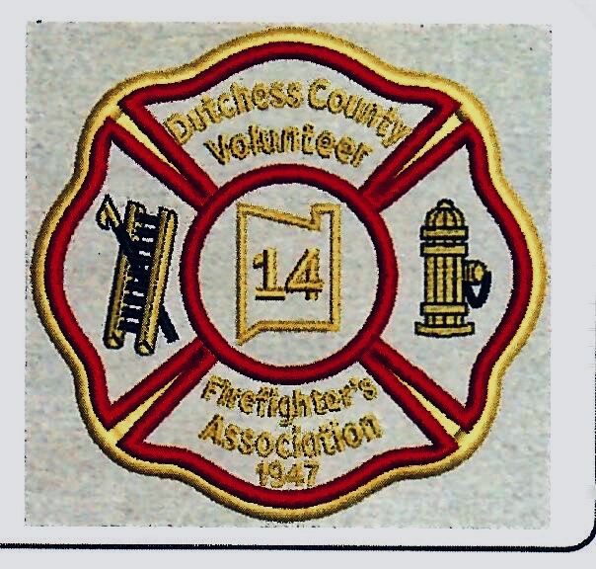
D.C.V.F.A. Scholarship Application
Name of Applicant______________________________________________________________ ___
Relation to DCVFA Member_______________________________________________________

Fire Department Member belongs to __________________________________________________

High School Applicant goes to_____________________________________________________________

College that Applicant will be attending in the fall of 2026*_____________________________________

What Volunteer work has Applicant has done for their Fire Department? _________________________
____________________________________________________________________________________
Contact number and email of Applicant____________________________________________________
Write a 250-word essay on one of the following. Questions about the essay? Email
  - What is the importance of the fire service in your community?
  - Tell us about a firefighter in your community; what impact have they had?
*Submit a copy of the acceptance letter from the college Applicant is attending.

Signature of Applicant__________________________________________________________________
Send completed application to:
Dutchess County Volunteer Firefighter’s Association
392 Creek Road
Poughkeepsie N.Y. 12601
Attention: Scholarship Committee.

Deadline: May 31, 2026

Dear Applicant,
Please complete the application on the reverse of this letter and submit with your essay and college acceptance letter by May 31, 2026. If you require any guidance concerning your essay or application, email Katherine Tolf at
Since this essay is part of a scholarship application for a limited number of scholarships, take the time to present a well thought out, grammatically correct essay on one of the two subjects provided. You may have competition for this scholarship- it is not a foregone conclusion that you will automatically receive one.
If your application is successful, you will be required to read your essay aloud at the annual convention at Millbrook Fire Department, June 16, 2026. Remember that the scholarships are funded by member dues, and your reading is a presentation to the members. Seven (7) scholarship winners in 2025 were successfully prepared for their presentation in this manner. The committee views this process as a learning opportunity and college preparation.
We look forward to receiving your application and essay. Good luck, and thank you and your family for your commitment to the volunteer firefighting community of Dutchess County.

Regards,
DCVFA
Scholarship Committee

